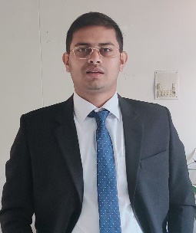**CV of MD. SAZZAD**

**HOSSAIN**

|  |  |  |
| --- | --- | --- |
| Name | : | MD.SAZZAD HOSSAIN SAGOR |
| Father’s Name | : | MD. HAFIZAR RAHMAN SAGOR |
| Mother’s Name | : | MOST.SABANA BEGUM |
| Date Of Birth | : | 15/01/2002 |
| Nationality | : | BANGLADESHI |
| Religion | : | ISLAM |
| Marital Status | : | SINGLE |
| Gender | : | MALE |
| Mobile Number | : | 01877131000 |
| Email | : | Sazzad131brur@gmail.com |
| Present Address |  | VILLAGE: SANDIAPUR, POST OFFICE: SANDIAPUR (5711), UPAZILA: SADULLAPUR, DISTRICT: GAIBANDHA. |
| Permanent Address |  | HALL: SHAHID MUKHTHER ELAHI HALL, BRUR, POST OFFICE: CADET COLLEGE (5400), UPAZILA: RANGPUR SADAR, DISTRICT: RANGPUR. |

**Educational Information:**

|  |  |  |  |  |  |
| --- | --- | --- | --- | --- | --- |
| Examination | Board/University | Result GPA | Group / Subject | Year | Duration |
| S.S.C | Dinajpur | 5.00 | Science | 2017 | N/A |
| H.S.C | Dinajpur | 4.42 | Humanities | 2019 | N/A |

**EXPERIENCE:**

* MICROSOFT WORD
* MICROSOFT EXCEL
* MICROSOFT POWERPOINT
* CONTENT WRITING
* CONTENT CREATE

**EXTRA-CURRICULLAR ACTIVITIES:**

* LEADERSHIP
* PLAYING CRICKET
* SWIMMING
* PLAYING BADMINTON